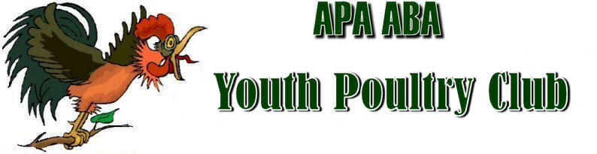

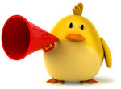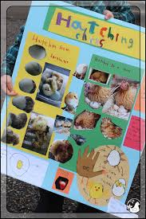

We will be having a poultry poster board contest. Bring any poultry related poster to the show for a fun contest. Classes will be determined at show.

